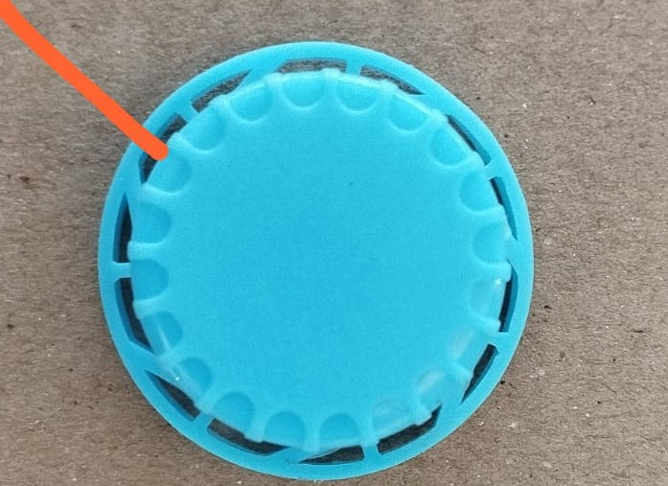

Top Surface of Bottle cap require Plain.

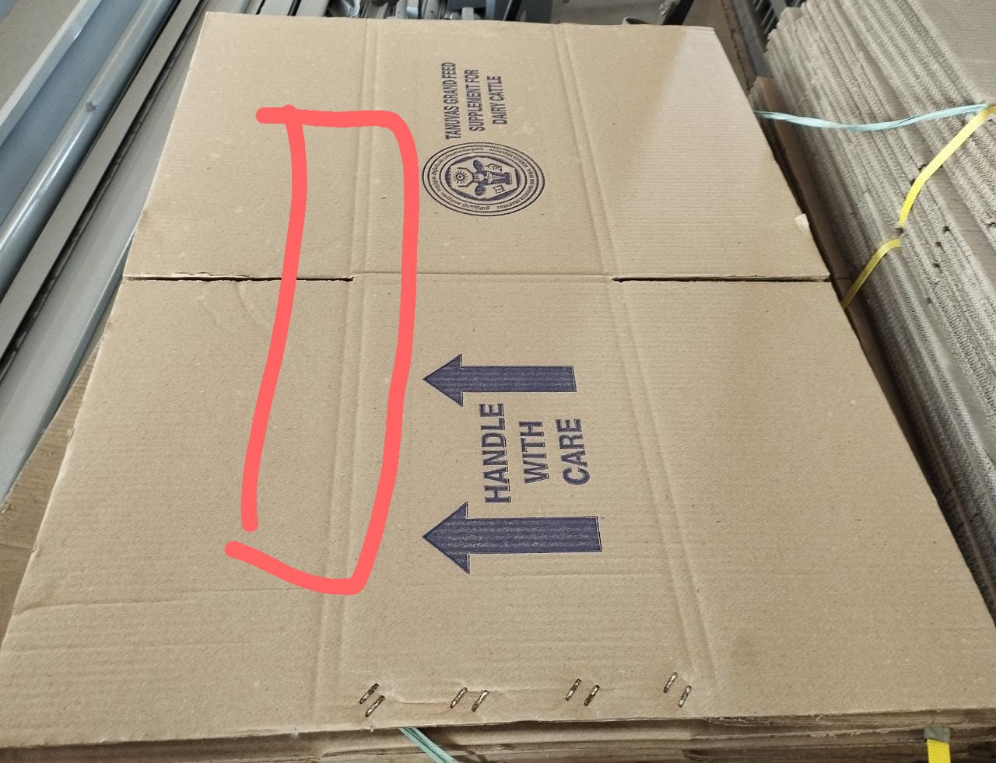

There should be single line instead of Double line.

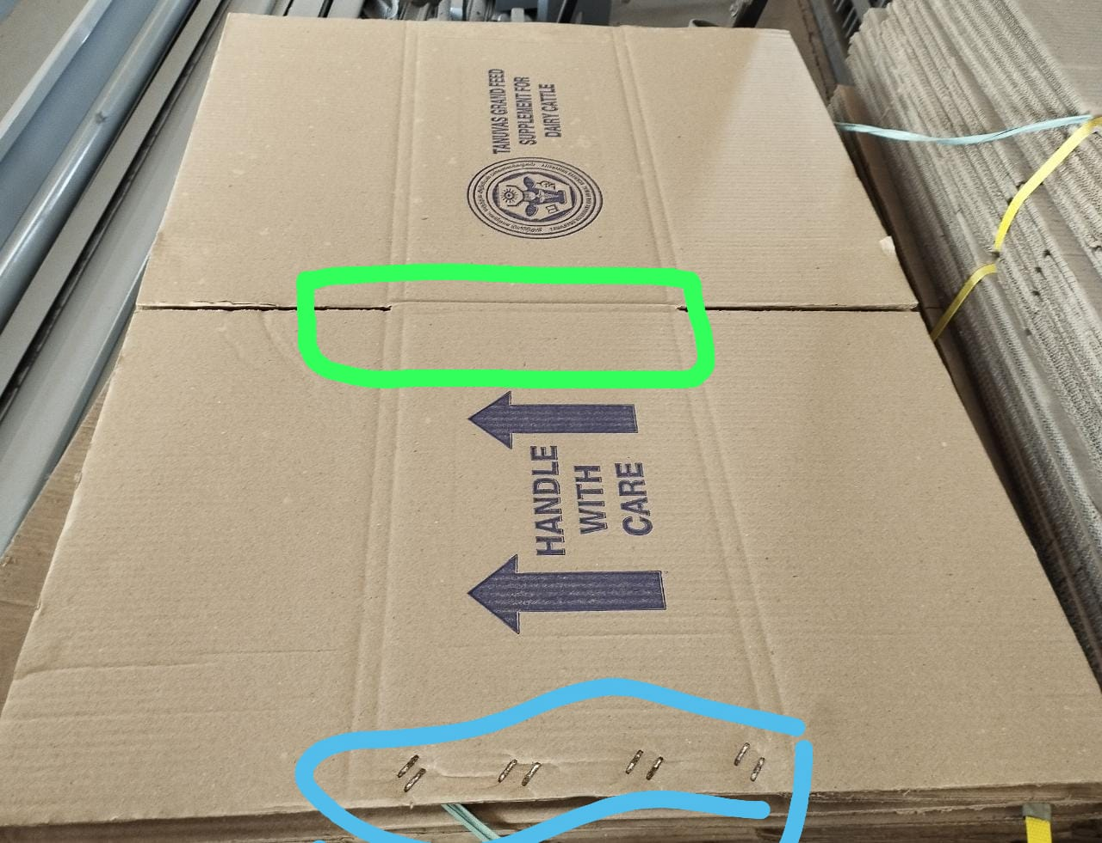

Stapple should be at center instead of corner.

